Present: Cllrs. Bovey, Distin, Giles, Nutley, Pugh, and Wood.
In attendance: The Clerk and Deputy Clerk.
Cllr. Pugh opened the meeting and requested a period of one minute silence in recognition of what would have been the late Queen’s 100th birthday.

034.26F Apologies.
The Clerk reported that apologies had been received from Cllr. Turner due to a prior commitment. Cllr. Giles proposed to accept these apologies; seconded by Cllr. Wood.
RESOLVED

035.26F Declarations of interest.
None.

036.26F Public comments and statements.
None.

037.26F To receive and approve the minutes of the previous meeting, 17th March 2026.
The Chair noted that all actions were complete. Cllr. Nutley proposed acceptance of these minutes; seconded by Cllr. Bovey. All in favour. The minutes were duly signed as a true and accurate record of the meeting.

038.26F Inspection of accounts.
The accounts were inspected by Cllr. Pugh. No anomalies found but she noted that several invoices are still in the name of the previous Clerk. These need to be amended.
ACTION: Clerk’s office to arrange change of details where the previous Clerk’s name is still shown on invoices.

039.26F Monthly Town Council income and expenditure details for March 2026.
The Clerk presented the Town Hall and Information Centre income and expenditure reports (Appendix 1). She advised Councillors that the annual business rates for 2026/27 have reduced relative to previous years. She was asked to circulate details of this to Councillors. The bank reconciliation was then presented to demonstrate financial accuracy within the accounting records.
ACTION: Clerk’s office to circulate details of business rates for the year 2026/27.

040.26F 2025/26 year end overview.
The Clerk presented the report. (Appendix 2). She noted that there is a possibility of a government grant to pay for the Neighbourhood Plan referendum when it is required.

041.26F To discuss options to gather public opinion regarding transfer of assets.
The Clerk reported her findings regarding the TDC poll, Post Office poll and other options, most of which are still quite expensive. The Post Office poll was the preferred option; additionally, there may be options, via Cllr. Rogers, of halving the postage costs. Discussion moved to who will pay the transfer/legal fees for any assets we may wish to take on. The Clerk’s office to contact TDC Estates Surveyor to ascertain this and take the information to the next Finance meeting.
ACTION: Clerk’s office obtain the transfer costs of any asset Ashburton Town Council may choose to take on.

042.26F To discuss upgrade to the CCTV.
The Clerk presented two quotes and explained the differences. Cllr. Wood proposed acceptance of the second quote; seconded by Cllr. Giles.
RESOLVED

043.26F To resolve fitting new castors to the Council tables.
The Clerk explained the reasoning behind needing new castors on the heavy Council tables. Advice to be sought from a local antiques expert. Depending on her advice a budget of a maximum of £500 was proposed by Cllr. Pugh and seconded by Cllr. Wood. All in favour of this course of action.
ACTION: Clerk to seek advice on new castors from a local expert.

044.26F Matters raised by Councillors for information only or possible inclusion on a future agenda.
Cllr. Distin noted that a new noticeboard for Balland Lane is in progress. Cllr. Wood reported that Wales and West have now agreed to pay compensation for the period the pool was forced to close last summer because of the roadworks. The Clerk reported that she had been asked about the electricity supply on Cleder for the food festival. It was agreed this topic will be put on a future agenda once decisions about the possible transfer of the area from TDC have been made.
ACTIONS: Move “Cleder Place electricity” to a future agenda and investigate a power supply.

045.26F PART II – To resolve that under the Public Bodies (Admission to Meetings) Act 1960 / Local Government Act 1972 (Schedule 12A), the public and press are excluded due to the confidential nature of the business to be transacted.
Cllr. Nutley proposed a move to a Part II discussion; seconded by Cllr. Wood. All in favour.

046.26F To receive an update regarding a staffing pension matter.
Discussion ensued. Cllr. Pugh proposed that a meeting is arranged and a letter hand delivered at that time setting out repayment terms; seconded by Cllr. Wood. All in favour.
ACTION: Clerk’s office to arrange meeting.

Cllr. Pugh thanked those present and closed the meeting at 20.46

Signed …………………………………………… (Chair) Date …………………………….

Action Points Arising from the Finance Committee Meeting
Held on Tuesday 21st April 2026 at 7.30pm in the Council Chambers

038.26F Inspection of accounts.
Clerk’s office to arrange change of details where the previous Clerk’s name is still shown on invoices.

039.26F Monthly Town Council income and expenditure details for March 2026.
Clerk’s office to circulate details of business rates for the year 2026/27.

041.26F To discuss options to gather public opinion regarding transfer of assets.
Clerk’s office obtain the transfer costs of any asset Ashburton Town Council may choose to take on.

043.26F To resolve fitting new castors to the Council tables.
Clerk to seek advice on new castors from a local expert.

044.26F Matters raised by Councillors for information only or possible inclusion on a future agenda.
Move “Cleder” to a future agenda and investigate a power supply.

046.26F To receive an update regarding a staffing pension matter.
Clerk’s office to arrange meeting.

APPENDIX 1 ITEM - 039.26F

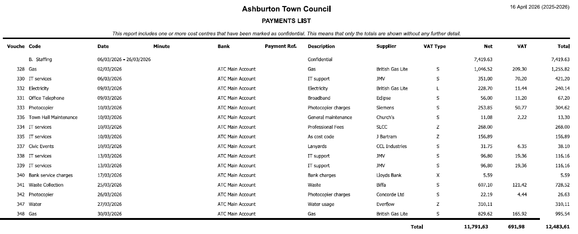

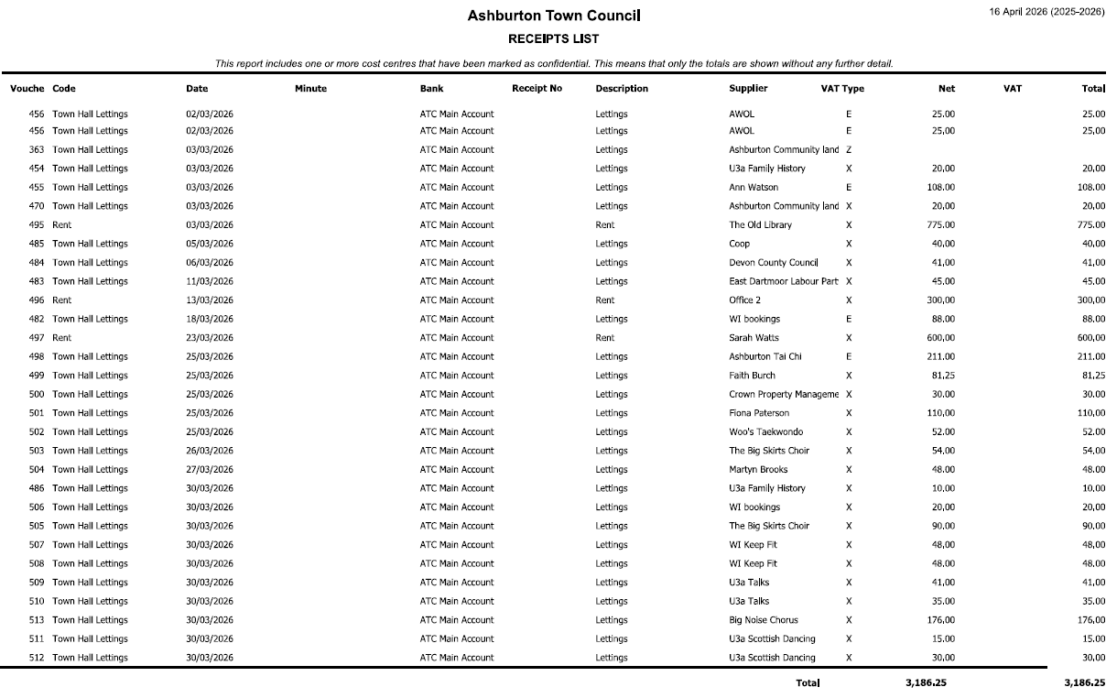

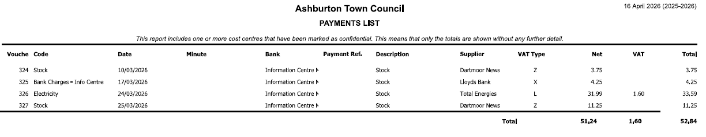

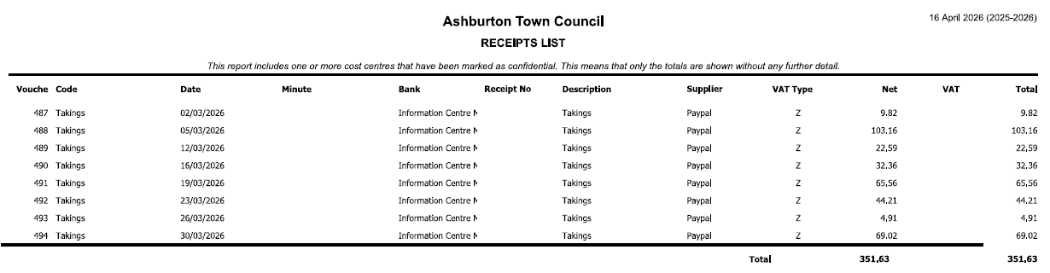

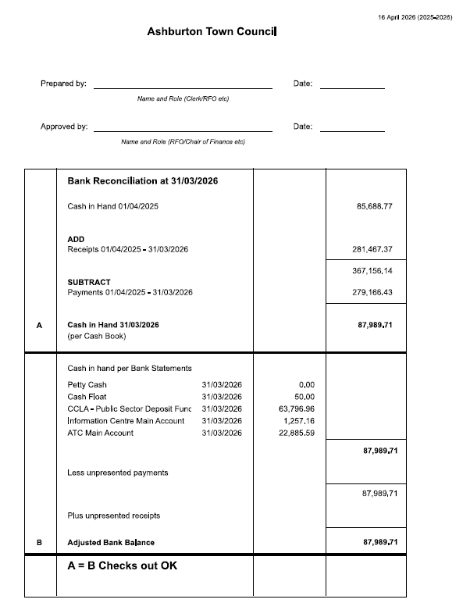

APPENDIX 2 ITEM - 040.26F
